Project Development Phase
Functional & Performance Testing
Date | 04 September 2026
Student Name | Pulibanti Tejavani
Project Name | Metro Ticket Generating System
Maximum Marks

Test Scenarios & Results
Test ID | Scenario | Expected Result | Status
TC-01 | Open Service Portal | Metro portal homepage loads successfully | Pass
TC-02 | Open Metro Ticket Catalog | Book a Metro Ticket catalog item is displayed | Pass
TC-03 | Select Starting Station | Available station can be selected | Pass
TC-04 | Select Destination Station | Destination station is selected correctly | Pass
TC-05 | Select Journey Type | Single/Return journey option works correctly | Pass
TC-06 | Enter Passenger Count | Passenger count is accepted and validated | Pass
TC-07 | Fare Calculation | Fare is calculated according to journey details | Pass
TC-08 | Select Payment Mode | Payment option can be selected correctly | Pass
TC-09 | Submit Ticket Request | Ticket request is created successfully | Pass
TC-10 | Generate QR Ticket | Digital QR ticket is displayed for verification | Pass

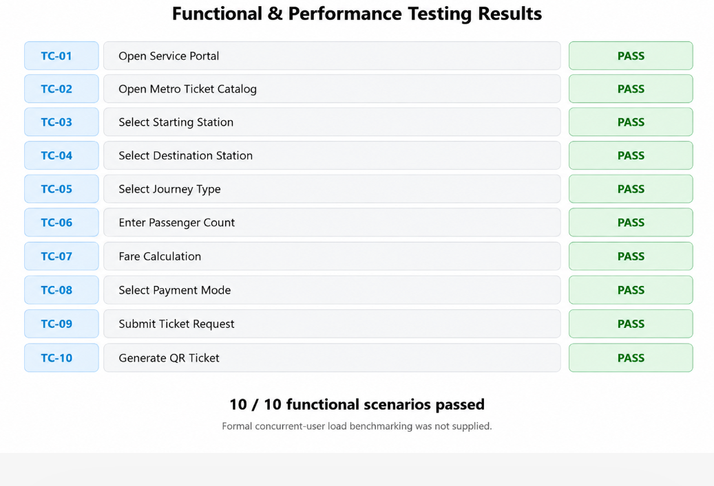
Figure 1: Functional test result representation.
Functional and interactive testing was performed for the implemented ServiceNow portal workflow. Formal concurrent-user load or stress benchmarking was not performed.

